Rationale Development Process

When I first started to develop my CSS, my main goal was to understand the layout in which I would like my website. Through research I established a good understanding of what makes a website accessible and user-friendly. From my analysis I discovered I wanted the layout to centered in the within the window. I then went on to choose the typography for the aesthetic purposes of the website. Even though the colors and type I have chosen may not be in the final design, they are similar to what I hope to achieve in the third assignment. I don’t want my design too be too bright and distracting from the websites content. I read many articles stating that the content should not be too ‘visually complex’ and as a result a simplistic design was what I decided on (Walker, 2013). The statement ‘less is more’ was very evident through my research (Smith, 2016).

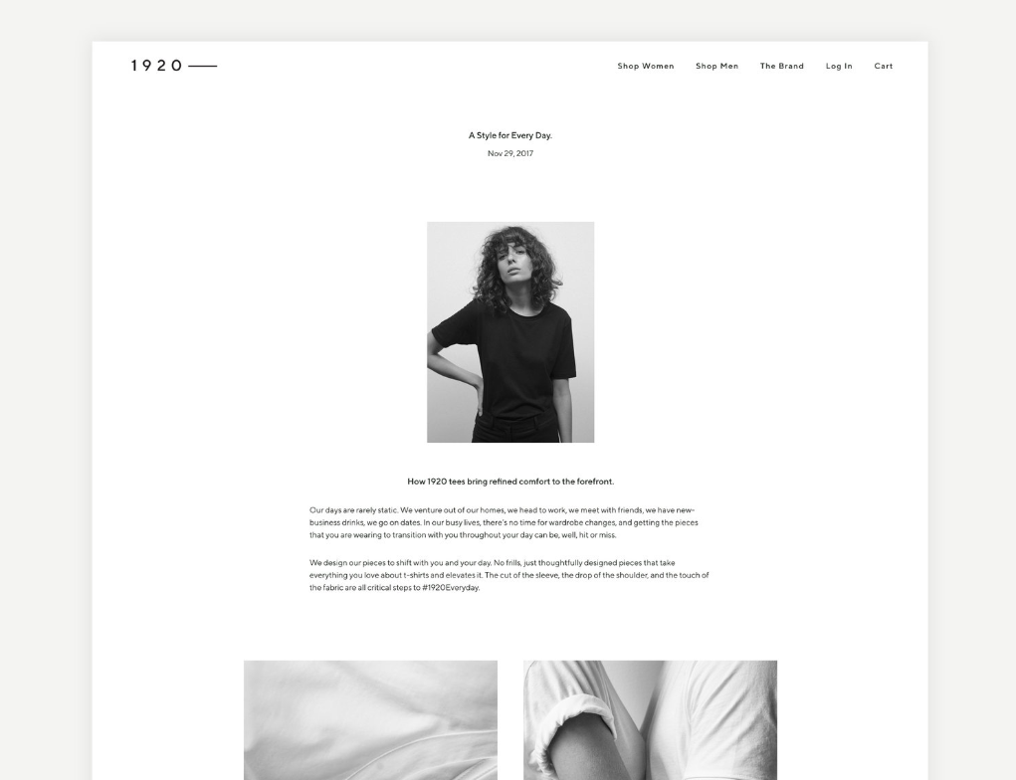Some examples I found online that inspired my design are:

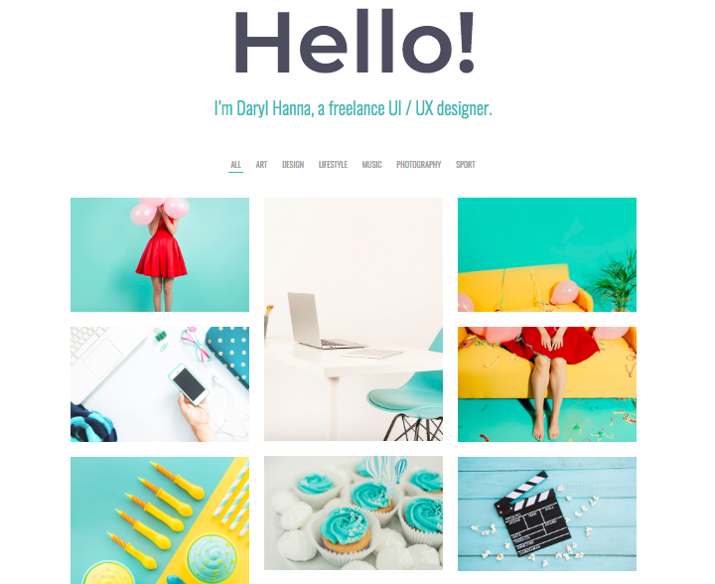(Ivansson, 2019)

(Hanna, 2019)

I liked the simplicity of the designs so I wanted to recreate something similar in my own design.

When I first developed the typography for this website I struggled adding the type from google fonts to the CSS page, however, I was able to make it work by adding the font links to the html and then changing the font family within the body of the CSS document. I started off trying to add very unique font such as:

‘Great Vibes’ for the titles

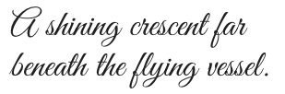

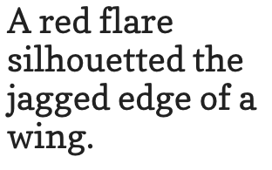And ‘Copse’ for the body text

However, It looked too messy and distracted the user from the information so I decided to use simpler font’s in order to present the information in a clear manner. I eventually decided on:

‘Rozha One’

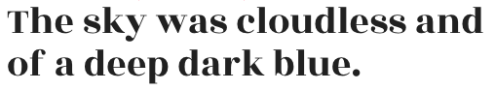

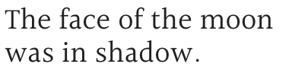And ‘Halant’

After developing the typography and box model, I moved on to the styling of the images for the site. This was the area I struggled with the most as many of the images were either flipped the wrong way or extending way out of the parent sizes I allocated to them. I fixed this by changing the width of the documents to 100% and leaving the height as it was. Then when it came to rotating the images I had to use the ‘transform: rotate’ tag, from there I adjusted the padding and margins so it would fit to my text. In the final design I will adjust the padding and borders to make it more concise however, the current state of the layout has helped my understanding of margins and padding.

All of the work I have put into assignment two will help me to work towards the final design of my website in assignment 3. There are still multiple things that I would like to add to Assignment three, however I now have a developed understanding of CSS through this assignment. I will develop the navigation links further and create a document with multiple webpages, as I believe this well help with the flow of the website. I will also further develop the image sizes within the website in order to make it look more professional. I also would like to add more decoration to either the navigation, text or images in order for it to become more interactive and user-friendly.

There is a lot of information included within the website, therefore, accessibility and flow are one of the major elements I hope to achieve in my final design. I want the information presented on the website to direct users towards the images. In doing so I hope to create a cohesive website, easy and transparent to any user.

References:

My Github Link:

https://github.com/sarahsliwinski/front-end-webdesigns1

Hannah, D. (2019). *Freelancer Portfolio – Lavr*. [online] Promo-theme.com. Available at: https://promo-theme.com/lavr/freelancer-portfolio/ [Accessed 11 Mar. 2019].

Ivansson, E. (2019). *1920 — Emelie Ivansson*. [online] Emelie Ivansson. Available at: https://www.emelieivansson.com/1920everyday [Accessed 13 Mar. 2019].

Smith, A. (2016). *Less Is Still More: The Importance Of The Minimalist Approach To Web Design - Usability Geek*. [online] Usability Geek. Available at: https://usabilitygeek.com/less-is-more-importance-minimalist-web-design/ [Accessed 8 Mar. 2019].

Walker, T. (2013). *Why "Simple" Websites Are Scientifically Better*. [online] CXL. Available at: https://conversionxl.com/blog/why-simple-websites-are-scientifically-better/ [Accessed 11 Mar. 2019].